Hurling & Football Coaching Co-Ordinators Report 2018
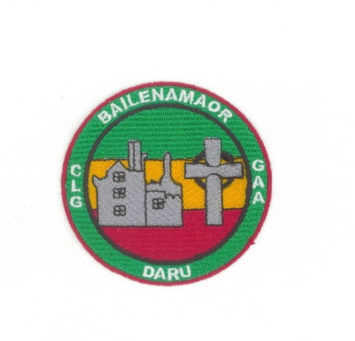
Football:
BD Boys & Girls football coaching structure:
An effective club coaching structure is the arrangement of competent and knowledgeable club personnel in such a way that quality coaching can be delivered to develop and progress players. The structure should be sustainable and involve a coaching committee, coaching officer and coaches working towards an agreed long-term coaching plan, whilst delivering set targets and objectives at each age level.
In Ballinamere/Durrow, we ensure we have an organised and structured coaching development plan in place, which is developed and implemented to maximize the talents of our underage coaches. We have ensured our coaches are properly educated, empowered and prepared to deliver a coordinated, integrated and enjoyable football coaching plan, which maximizes the potential of all our boys & girls.
2018 began with coaching team selections. This is a hard but worthwhile task. Various checklists & evaluations are performed on each coach before including them in team managements. All of our coaches have achieved child protection & coaching awards plus being Garda Cleared. Our coaches were then all registered to our parent clubs and to the LFGA.
Football in Ballinamere/Durrow is now at an “A” county standard for boys & girls for the first time ever. Hard work with basic skill development and fitness fundamentals have helped reach this target.
However, this is not guaranteed each year. Football coaching is hard. We need to ensure our coaches at underage (U12 down boys & girls) concentrate on skills-based sessions, including the 20 basic skills of football are developed before these players reach championship level (U12 up). Matches during training at this age group only develops certain players. In 2019, the exec need ensure that all underage boys/girls teams concentrate on fitness & skills and leave matches to the organised blitz days.
For championship teams, fitness & skill development are also vital. Coaches need to ensure players make the correct decisions during matches by creating appropriate game-based drills in training. This will improve awareness on match days, which I believe is a skill we are lacking in BD. Fitness with the ball is essential to ensure all players can keep going for 60 minutes of championship action.
Coaches need to be constantly conscious of the fact that if a boy/girl are not performing a particular skill well or making an incorrect decision on the field..maybe they have not been coached to do it correctly.
Rotation of team coaches helps invent new ideas and creates new beginnings for players, this works only if our coaches continue to promote the form of football that is working best for BD currently.
We will continue to strive for perfection each year, encouraging that all our girls & boys play fit football in a positive way and are prepared correctly throughout the years in the BD underage structure.
Thanks to all our coaches for Your hard work and dedication to the development. Skill cards and age appropriate drills will be again provided in January. Please start 2019 by posting Your session on team Whats App groups.
If any parents would like to get involved in coaching please contact.
Carina/John
Hurling Report
I want to start by thanking all our coaches for their fantastic work throughout the year.
I doubt that any club have such a committed and organised group of coaches.
Nursery to U11.
I think that we have made very good progress at these age groups with much more emphasis on the basic skills.
I know I am constantly harping on about it but it cannot be over emphasised the importance of the basics.
I would like also to see a bit more emphasis next year on Fitness/Agility/Balance in our sessions. The standard at which a player plays at a later stage is usually defined by pace, for the most part the lower levels contain the slower players so their has to be emphasis on this area.
Coaches constantly complain about young players not practicing between sessions and I can understand it and I know it will not always work but giving them homework and encouraging them to go to matches helps develop a love of the game which in turn gets them into the habit of playing at home.

Under 13 to Minor.

A lot of great work done again at these age groups and we were slightly unlucky particularly at U15 not to bring home some silverware.
Again I would like a bit more emphasis on Agility /Balance in particular.
I do think at these age groups we could improve tactically particularly in the area of puckouts support play and field positions.
The next area I feel we could improve on is in the organisation of our management teams on the match days. Managements should be much closer together on the side-line and know their roles .Issues such as organising umpires and linesman on match days is hugely important and should be done by a member of management or delegates to someone.The winning of a championship usually involves winning or losing a match by 1 point so umpires are very important.
I want to finish by saying that the future of the club will be directly related to the standard of our coaching and really all players deserve and are entitled to good coaching.

Pat Cleary
Coaching Officer Hurling

